

SESSION: 2017/18

**Module Title: Data Structures & Algorithms**

**Module Code: M2I224180**

**Level:** 3

|  |  |  |
| --- | --- | --- |
| **Student Name** | **Student ID** | **Student E-mail** |
| Thakane Juliet Selebalo | S1719043 | Tseleba200@caledonian.ac.uk  Tselebalo15@alustudent.com |

“This piece of work is my own original work and has not been submitted elsewhere in fulfilment of the requirement of this or any other award.”

**Results From Running The ContactTest**

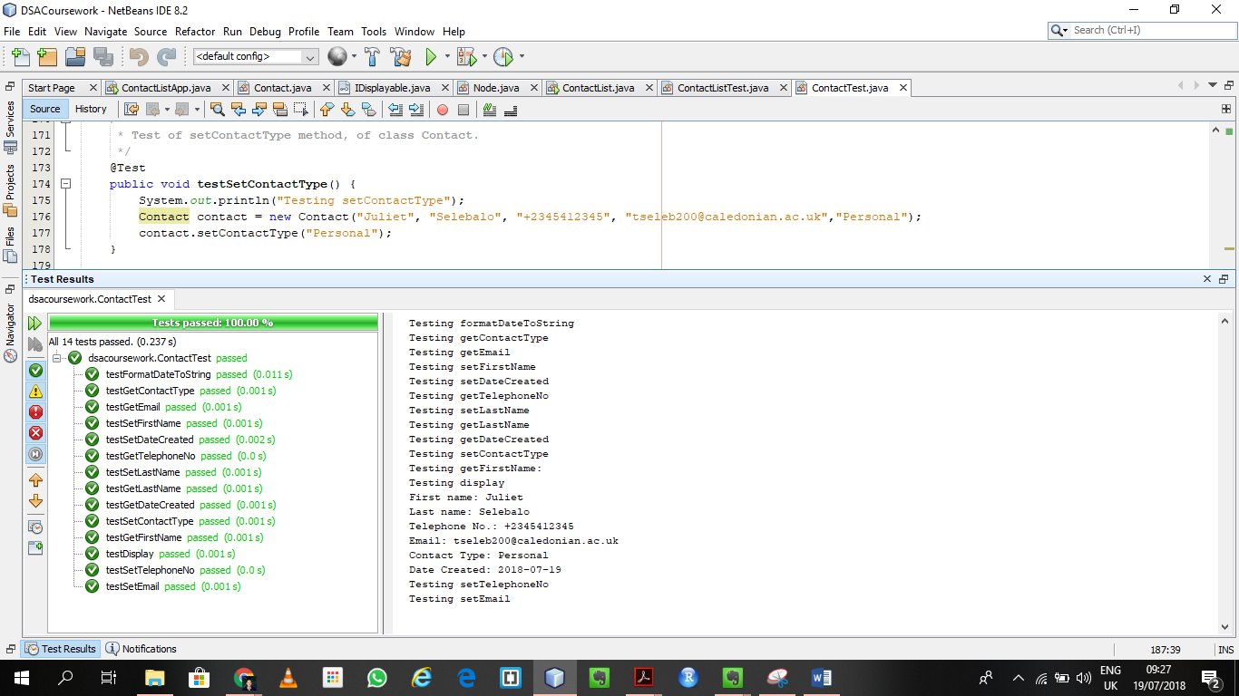

**Results From Running ContactListTest**

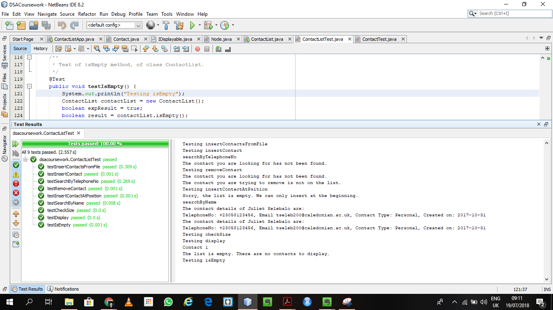

**Testing the ContactListApp**

1. **Create Contact**

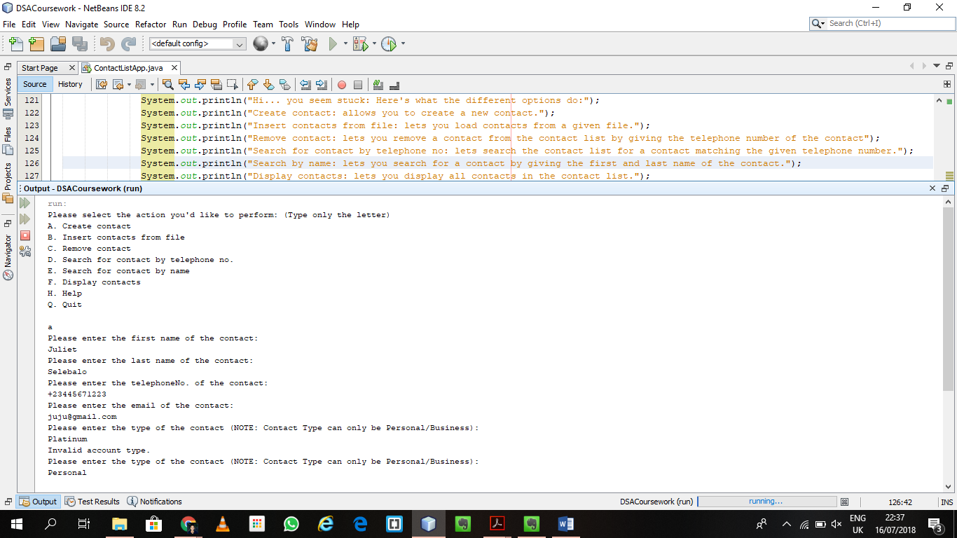

1. **Testing the insert contacts from file option**

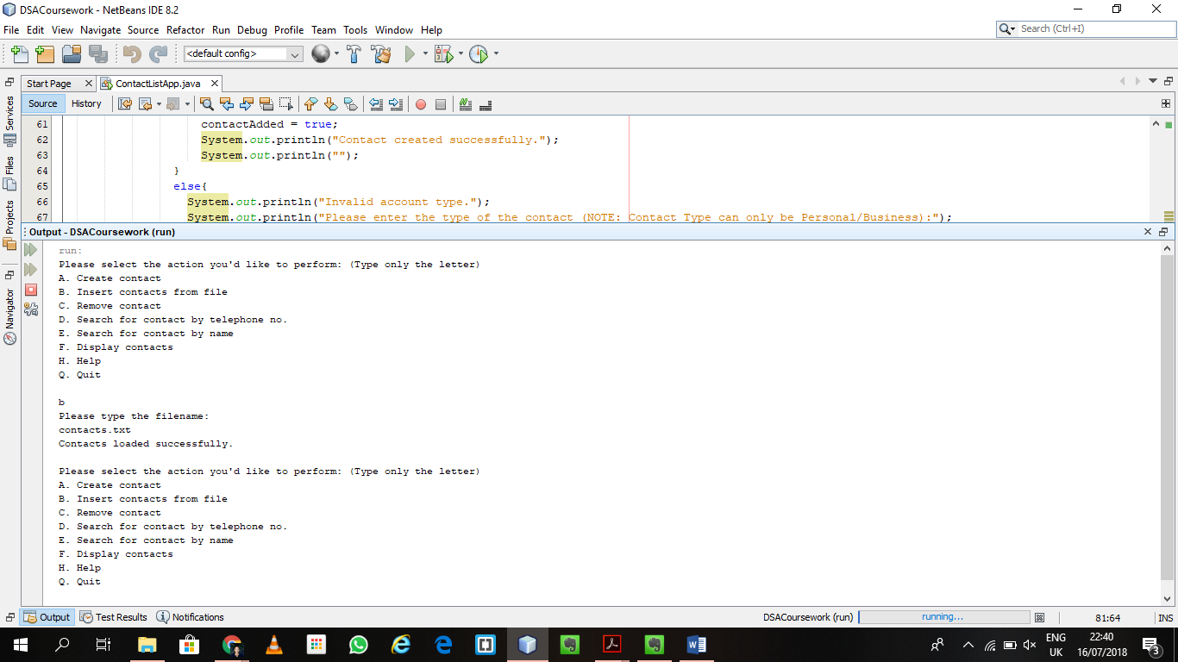

**Display shows all the contacts have been loaded**

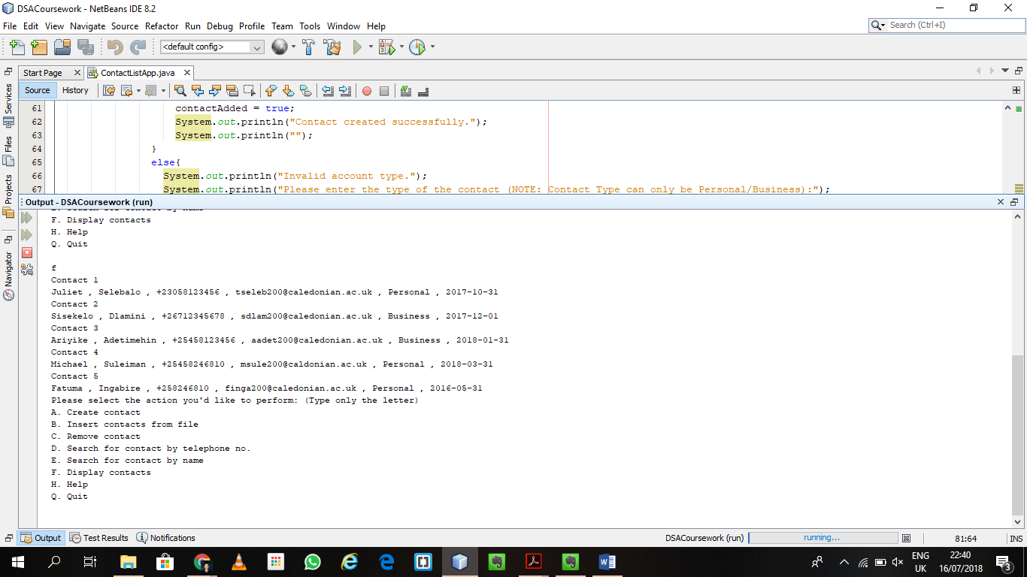

1. **Testing the Remove Contact option**

First we display the contacts to confirm the list actually contains contacts

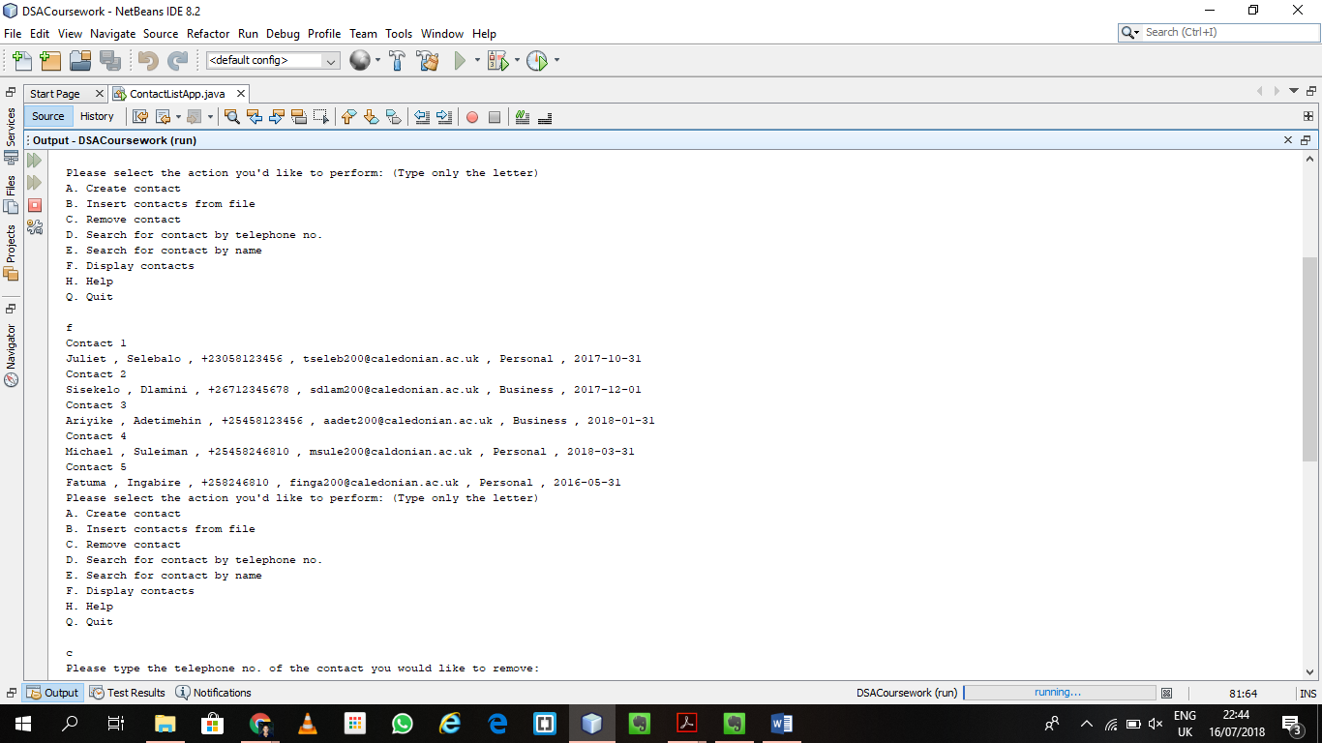

Then we select remove contact and enter the phone number

Screen 1 (when contact is on the list)

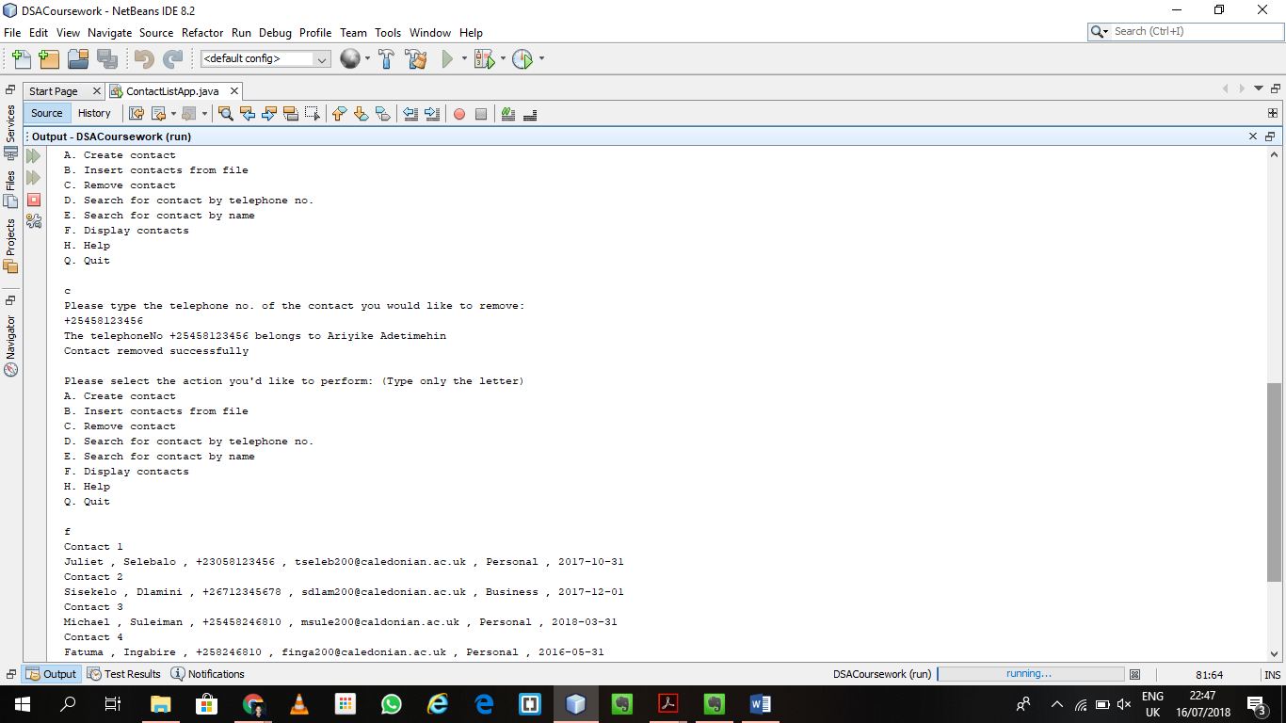

Screen 2 (when contact is not on the list)

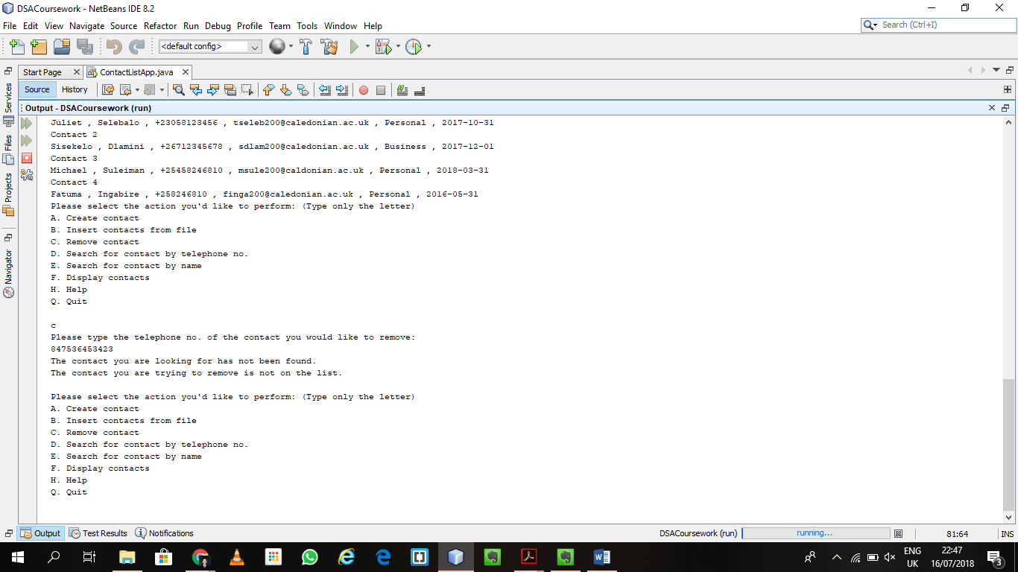

1. **Search For Contact By Telephone No**

When contact is not on the list

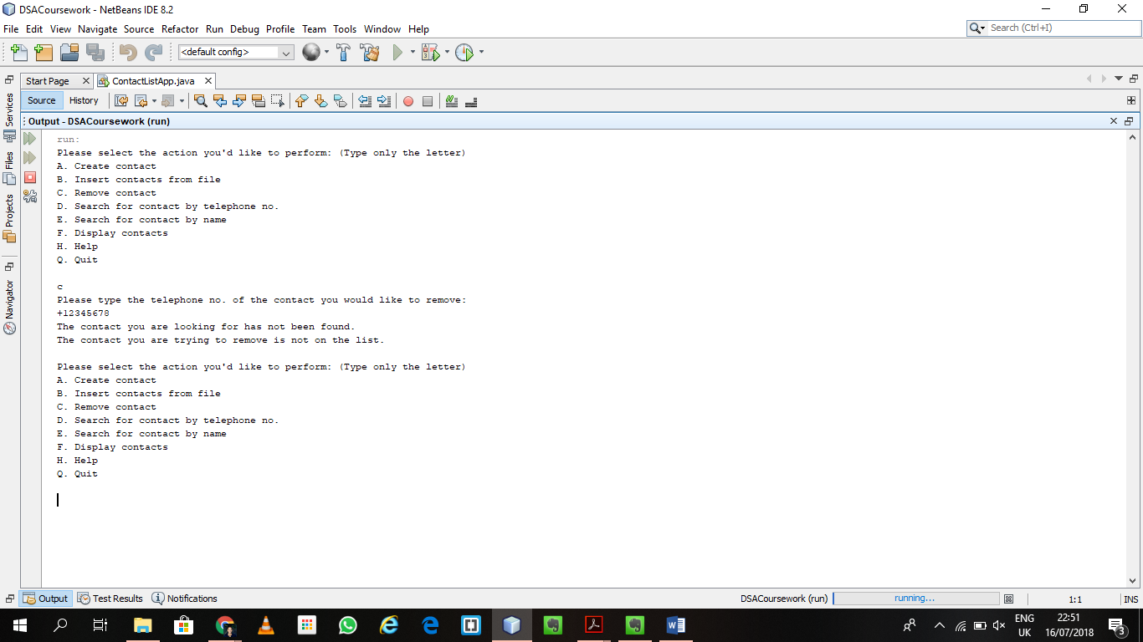

When contact is on the list

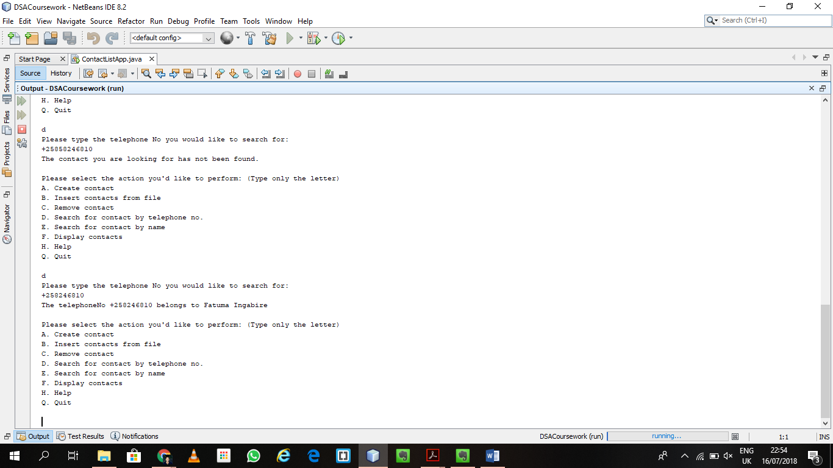

1. **Searching For Contact By Name**

When the contact is not on the list

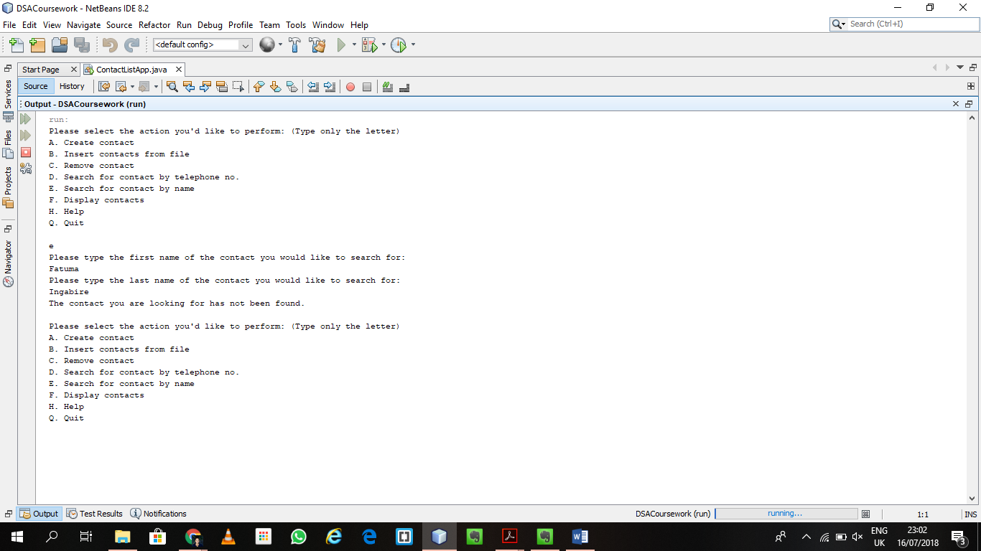

When the contact is on the list

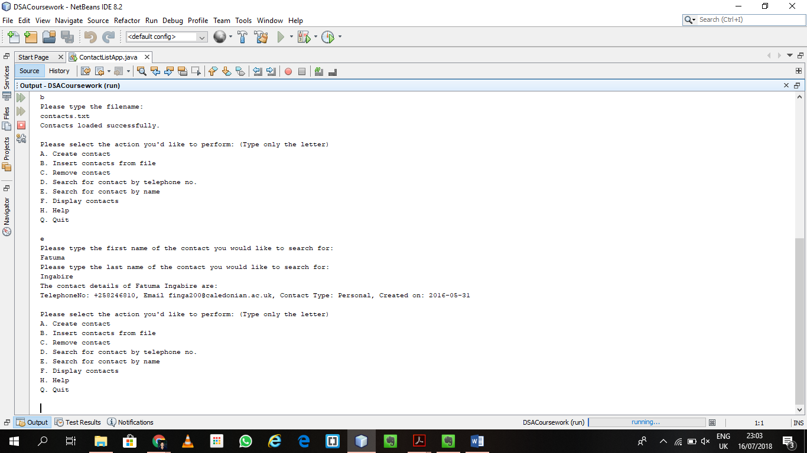

1. **Testing the Display Contacts Option**

When the list has elements

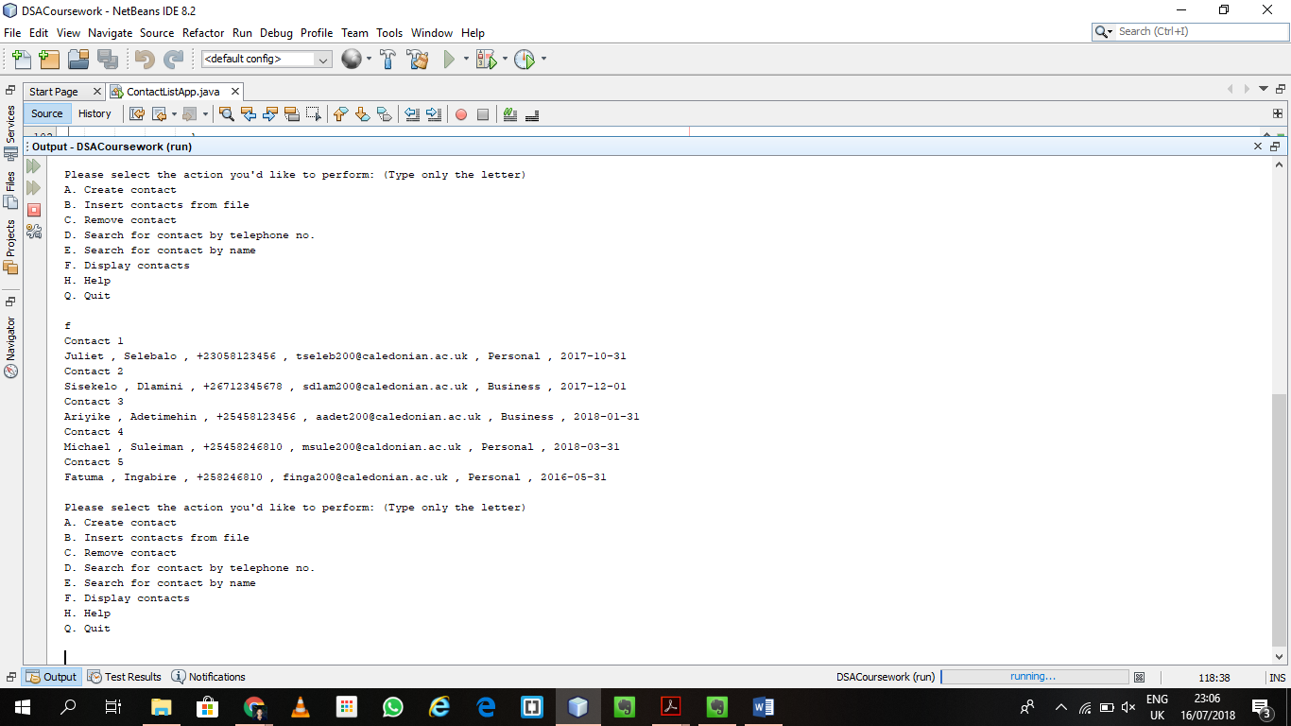

When the list is empty

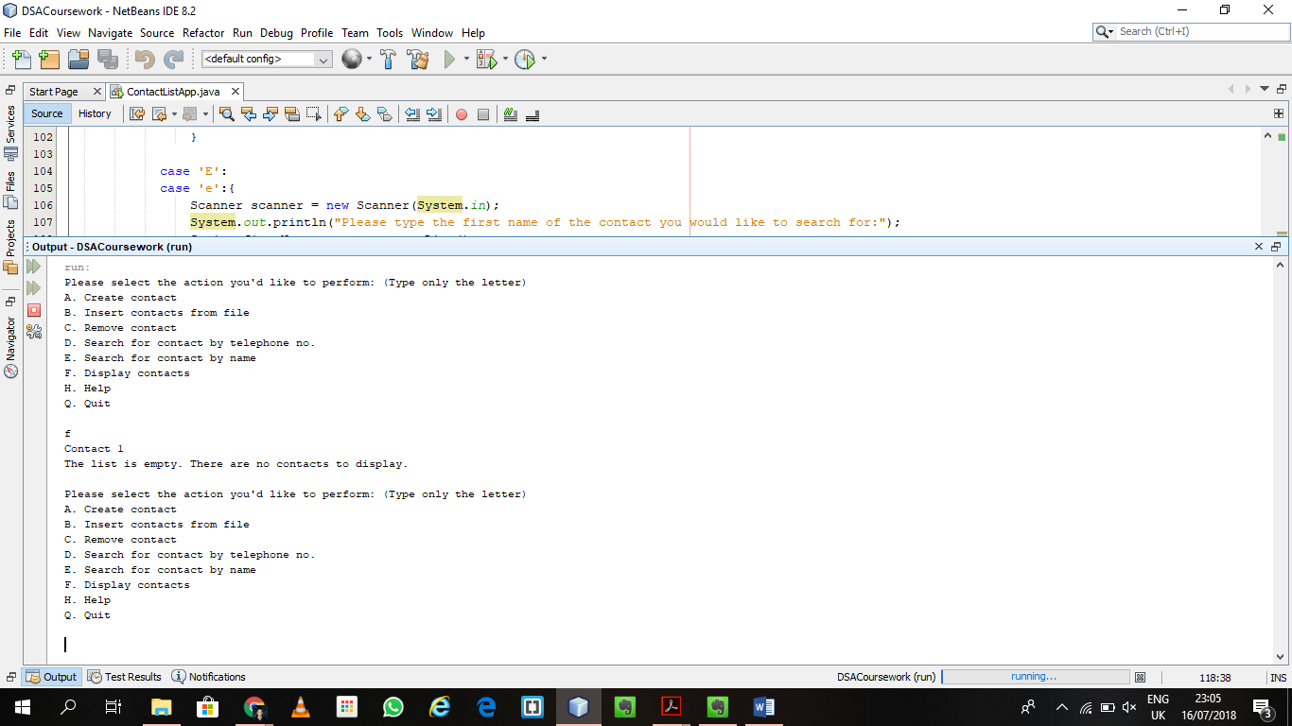

1. **Testing the Help Option (**describes what each option does and sends a note to the user about how to pick what to do**)**

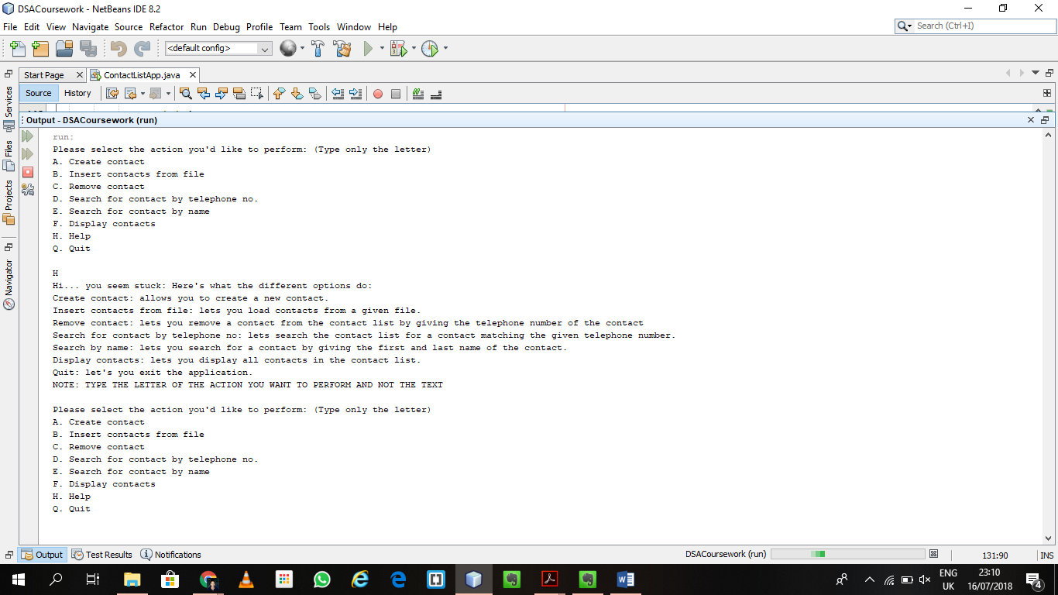

1. **Testing the Quit Option (**stops the application**)**

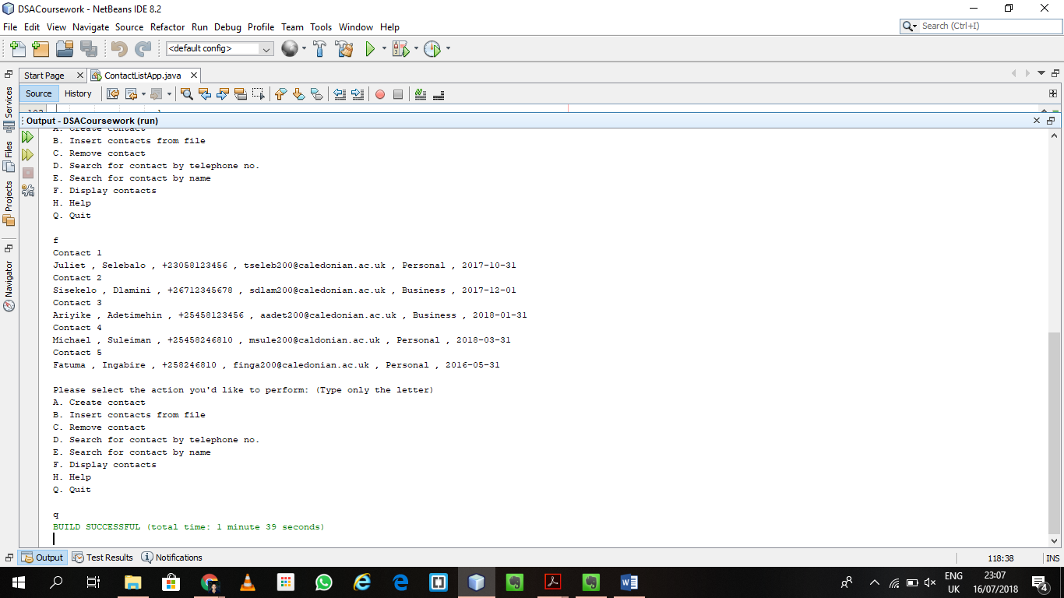

**RESULTS FROM RUNNING JAVADOC**

**Can be found in:** S1719043_Selebalo_cwSection1\dist\javadoc

**NOTE:** start from the index page then move to individual classes

**Issues with the Javadoc**

* In the .java files, the documentation for the prev field of Node is correct. However, the generated Javadoc describes prev as pointing to the next node which is incorrect and not as indicated in Node.java
* In the ContactList class, the field current’s Javadoc comment is written as “keeps track of the currently selected node for the doubly linked list”. However, the generated Javadoc indicates that current “keeps track of the starting node for the doubly linked list”
* This also applies for the end field of ContactList where in the ContactList the Javadoc describes it as “keeps track of the end node for the doubly linked list”. However, in the generated Javadoc output is also described as “keeps track of the starting node for the doubly linked list”